SETTING UP MobileREX
STEP 1: You will now receive an email invite from Track n Trace to log in once you have paid your subscription.
See example below.
-----Original Message-----
From: MobileRex <mobilerex@trackntrace.com.au>
Sent: Monday, 13 January 2025 12:44 PM
To: tim@trackntrace.com.au
Subject: Welcome to MobileRex
Hi Tim,

Welcome to MobileRex!

Let's get you started in a few easy steps:

1. Download MobileRex APK file into your device(s) from this link: https://www.trackntrace.com.au/MobileRex

2. Navigate to the device directory where you downloaded the APK, and tap on it to install

3. Use the below credentials to log in to MobileRex:

Email: tim@trackntrace.com.au
Temp Password: 7#%C0451
For helpful information about getting started, checkout the below link. If you have additional questions or need assistance getting started, contact us directly and we’ll be happy to help.
https://www.trackntrace.com.au/product/mobilerex-support-page/

5. Once installed, open MobileREX in applications. Use the below credentials to log in to MobileRex:
Use your email address provided:
Use Temp Password Provided in Invite: Example: CA191FBD
You will then be prompted to enter new password. Please record this!
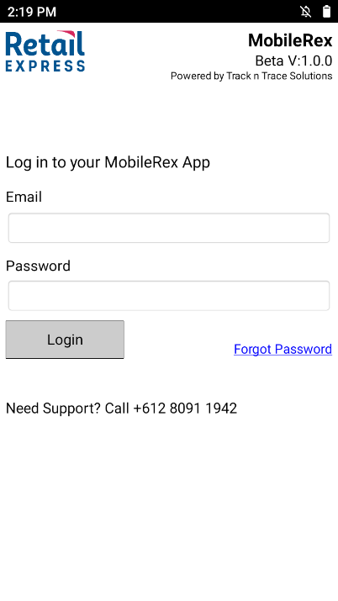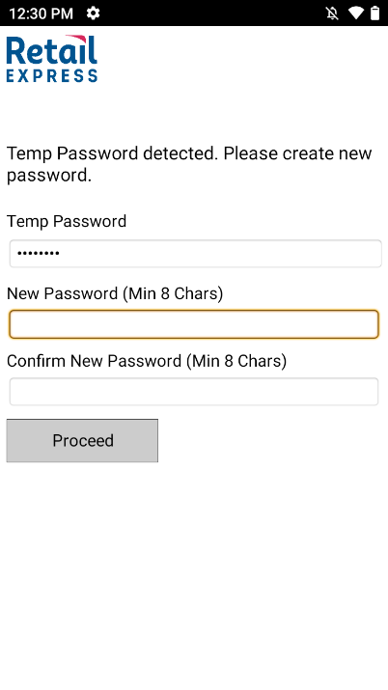
- To access MobileREX, you cannot proceed any further until your API key is setup. This connects the MobileREX app to your database. To setup your API Key in your Retail Express account. Go to Settings > Integrations > API Management.
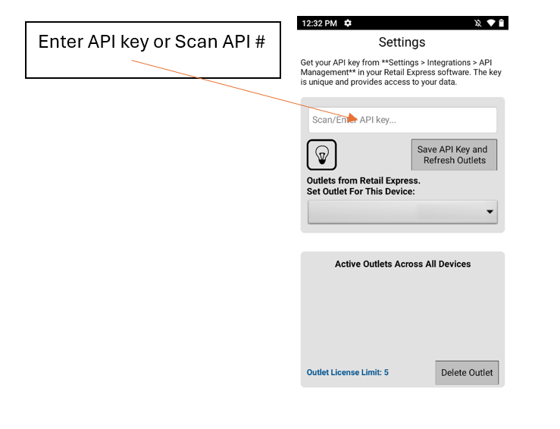

Once you have given an API key name and API Key Description, you can generate API key by clicking green button – Generate Keys
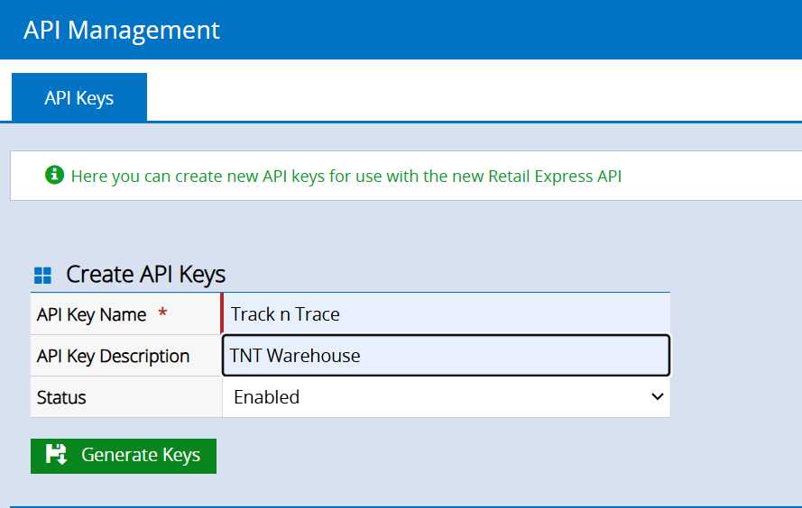
Scroll to bottom of page and choose Primary key that you have setup.
You need to insert this API 32 key # in to MobileREX app.
You can manually insert it or the easiest way is to go to a barcode generator site like link provided and create the barcode.
Barcode Generator Site - https://www.mobiledemand.com/barcode-generator
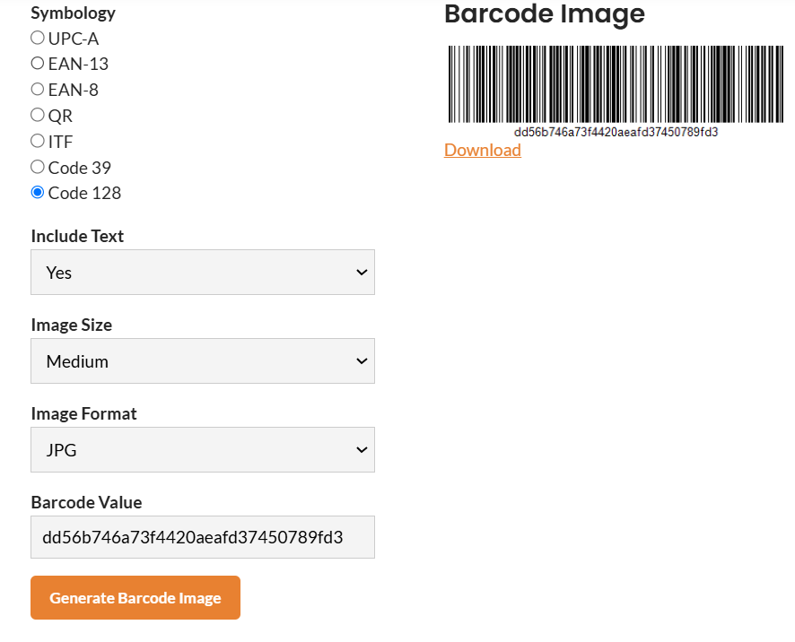
Then scan this barcode into the API field of MobileREX. Make sure your cursor is active in the API field of MobileREX and press scan buttons.
Select “Save API key and Refresh Outlets button
If you have multiple outlets, choose outlet you are working within. You are now ready to use MobileREX
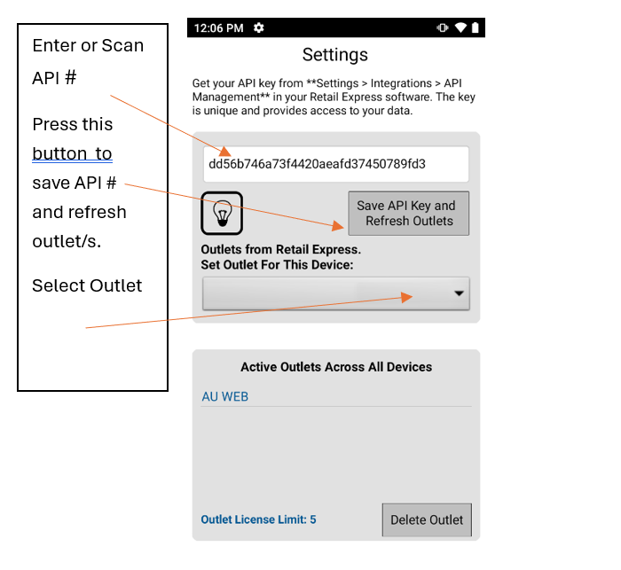
For helpful information about getting started, checkout the below link. Please also check the video on how to get started with MobileREX – Video Link
If you have additional questions or need assistance getting started, contact us directly at mobilerex@trackntrace.com.au and we’ll be happy to help.
https://www.trackntrace.com.au/product/mobilerex-support-page/

Thank you,
Track n Trace Solutions
Email: mobilerex@trackntrace.com.au
Ph: 1300 808 412

