To receipt POs – Click on Receipt Pos on your MobileREX app.
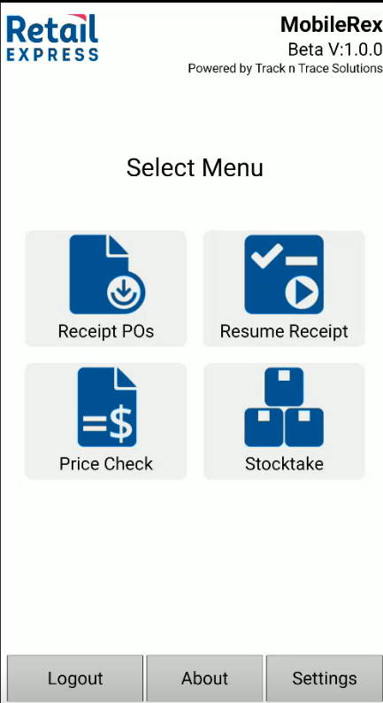
NOTE: Should highlight that if you have already started receipting a PO on your PC and it is in progress. You cannot complete this on MobileREX. This is a limitation of the API in Retail Express. If you try, you will get a warning come up on MobileREX screen. See below.
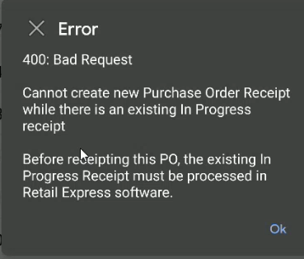
Once you have finalised or made available the stock you have scanned in Retail Express software against that PO, you can now use MobileREX to scan the rest of any items outstanding against that PO.

If we go into a Receipt Pos, you can either search for a PO by keying it in or you can select/touch on screen that PO. Once selected, click on blue button called Continue in top right hand corner.
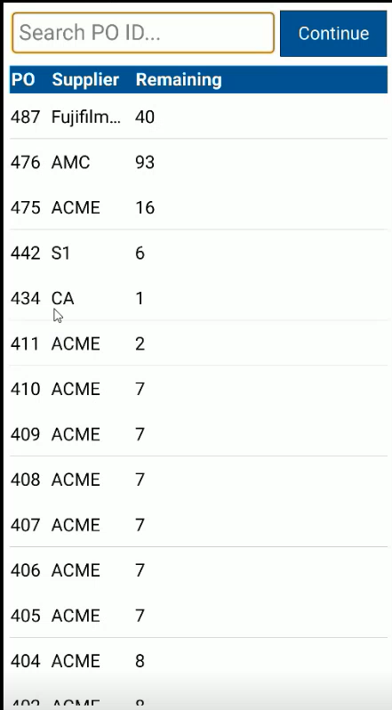
Once you are in that PO, you will be provided information of that supplier SKU # as well as description. Remaining items awaiting to be receipted as well if there has already been any items scanned previously against this PO.

Feature Descriptions on top of Screen
- Continuous scan - is if you need to scan every individual item rather than enter qty.
- Copy Across - Expected qty of PO rather than scanning or keying in qty
- Set 0 - If a mistake has been made with qty, just reset to back to 0
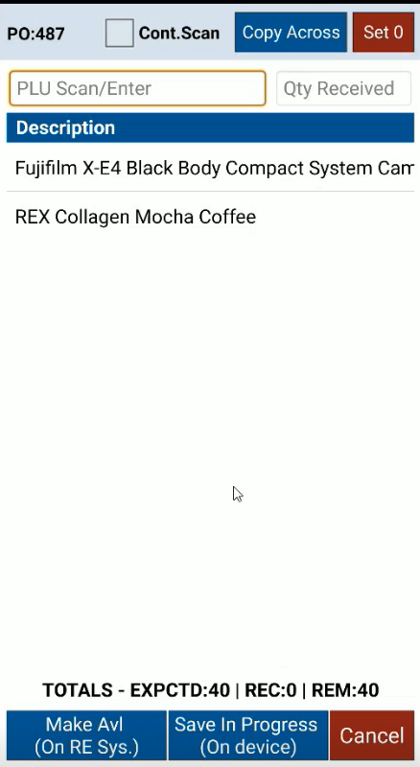
Feature Description on bottom of Screen.
- Make Avi (On Re System) - Once finished scanning, select Make Available button so it can update Retail Express SOH.
- Save in Progress (On Device) - Safety feature. Saves progress on device only. Go to Lunch. Come back to resume receipting where you left off.
- Cancel - Will discard any received quantities for this Purchase order

MobileREX – Receipt PO video - https://youtu.be/LNcxDJ1IpL4?si=WyVkvRy1Bvp9Za89
This video demonstrates the functionality of MobileREX - Receipt Purchase Orders. Giving examples of scanning and receipting purchase orders with an Android PDA scanner. MobileREX will connect directly to your Retail Express database via an API connection using Wi-Fi or 4G. If you are a single store or multi store business, it will allow you to choose which store you are receipting for and pull down all your POs into the MobileREX app, even while you are mobile and walking around your site. Retail Express customers will find MobileREX very intuitive as it uses the same functionality and terminology that Retail Express uses. MobileREX - Receipt POs increases efficiencies and allows stock received to be become instantly available allowing you to manage inventory in real time.

