MobileREX Stocktake Function – Live
NOTE: Always test Wi-Fi coverage across your store before using Live mode. If signal is slow and patchy, go to Troubleshooting section below.

- Login to MobileREX.
- Before logging in, you can also check for updates. Click on About button .
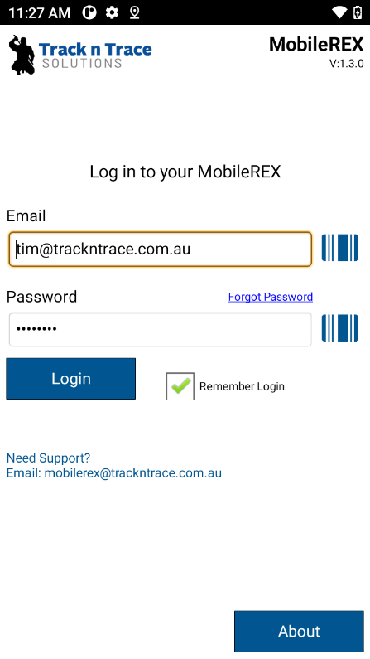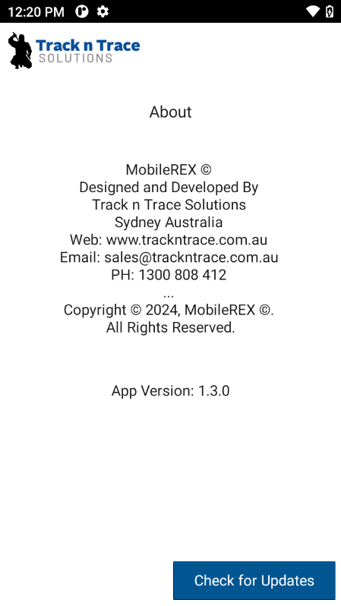

- First select Local Settings in bottom right hand corner of screen.
- Select Local Settings.
- Check Rex item lookup during stocktake box if creating a local lookup table and loading on to PDA scanner.
- Check Play Valid Alert Sounds and Play Invalid Alert Sounds boxes.
- Save local settings and go to Set REX API Key & Outlet
- If API key already present, select “Save API Key and or refresh Outlets button.
- Now Set outlet for this device. Select OK and will go back to Local Settings Screen.
- Select Back button to go back to main menu.
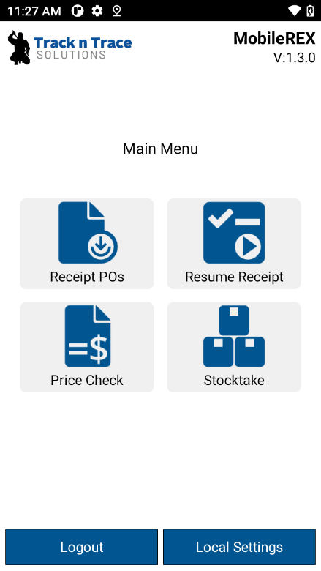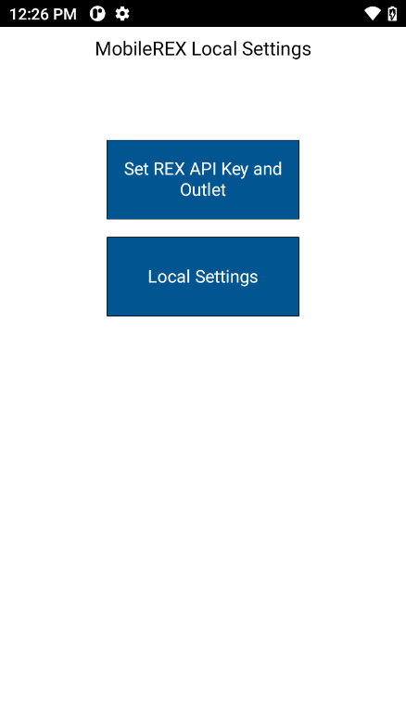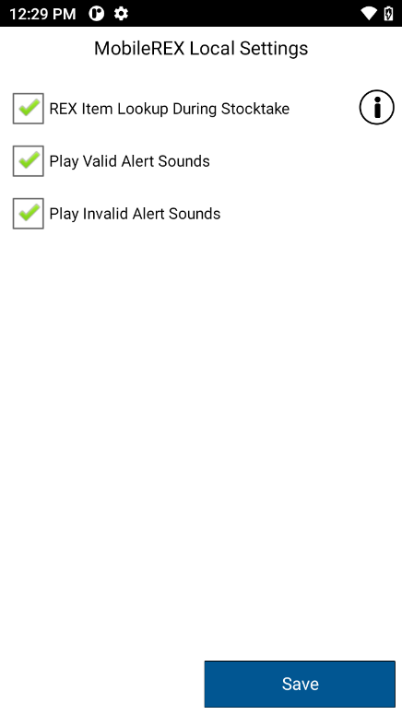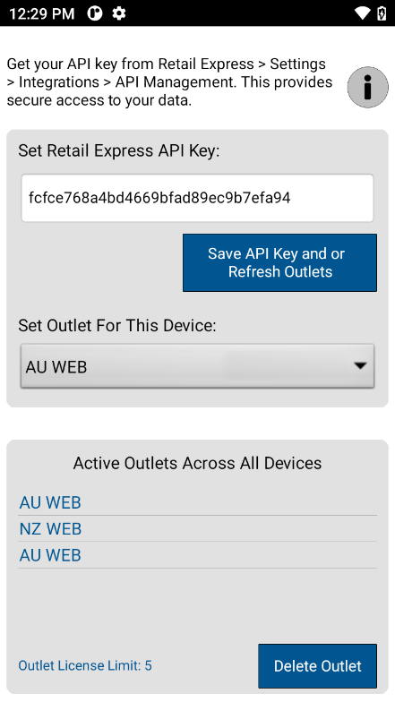

Start Stocktake
- Select Stocktake Function Button
- Select Email Settings button if you want to send stocktake data and end of stocktake by email.
- Select Start Stocktake Button. No need to import if just using Live API connection.
- Select Location ID # or Bin # if tracking this in Retail Express. Leave empty If not and select proceed.
- You can also now use camera to capture data. See barcode on right side of Bin/location field.
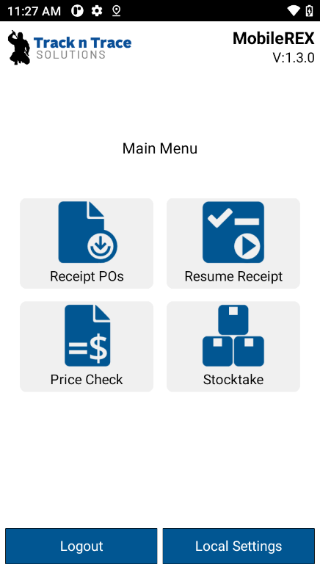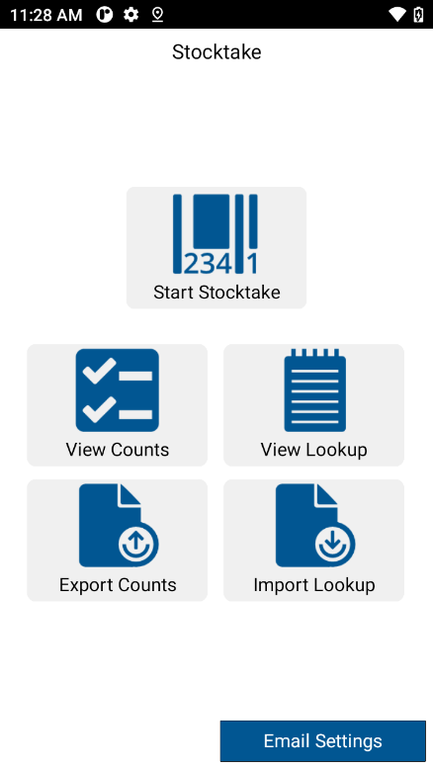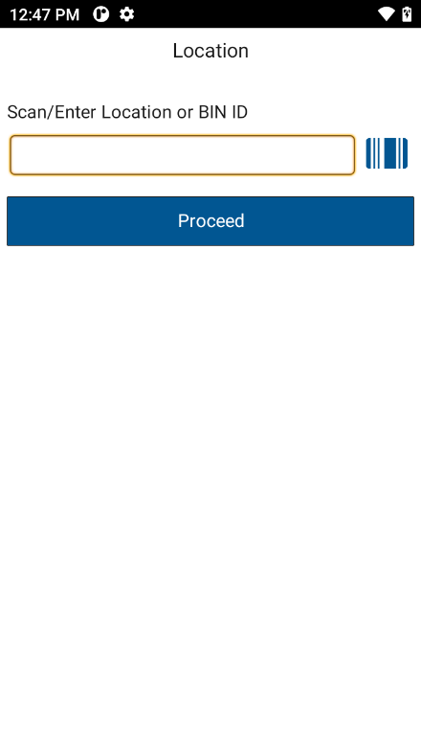

- Choose if you want to use camera (far right icon of PLU Scan/enter field). Keep in mind a camera needs to focus before capturing barcode #. Light conditions can severely hamper speed and efficiency. Always use the integrated 2D scan engine in a PDA scanner where possible.
- If scanning single items only, make sure you check the Auto Save box in right hand corner. It will automatically save a qty if 1 against each item scanned.
- For bulk or qty scanning, leave unchecked. After scanning an item, it will prompt you to enter a qty in qty field. You will need to select save after entering qty. Save button is top left hand corner. You can also save with your virtual keyboard.
- If there are duplications of same barcode ID # scanned, a screen will appear on your PDA scanner and you will be given a choice of required product to be counted.

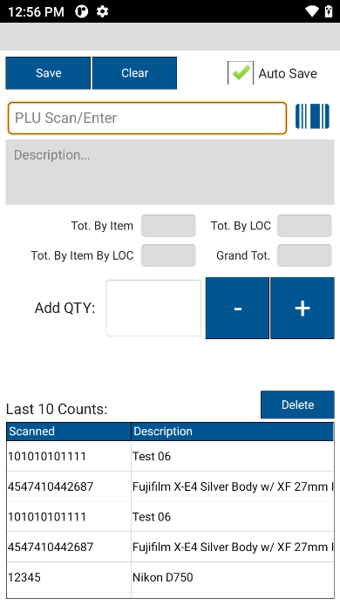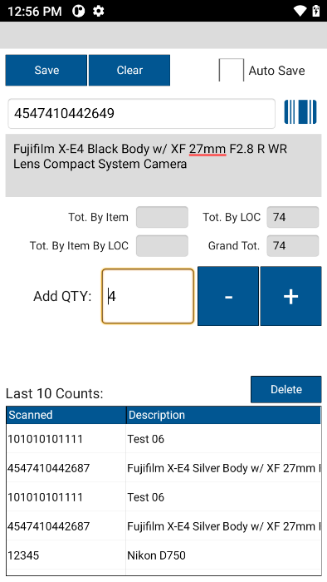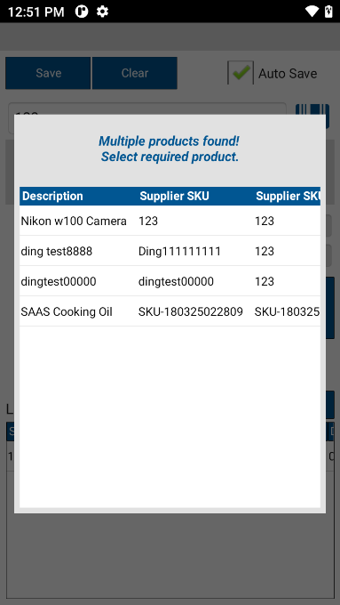
- Once stocktake is finished, escape (back button) back to BIN/Location Screen and then Escape again back to main menu.
- View Counts if need to see stocktake data counted such as Total By Location, Grand Total counted. Select item on screen or search item so you can view Total of item counted as well as Total of item by Location.
- If ready to export stocktake data, in Stocktake menu, select Export Counts. You will asked to either send data via email or Export to Internal memory.

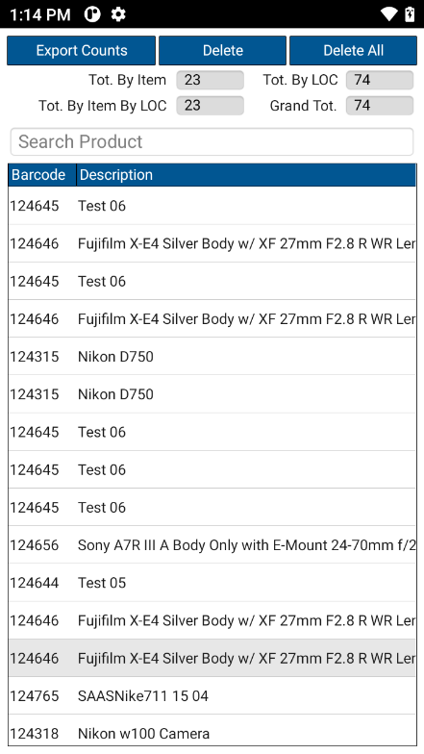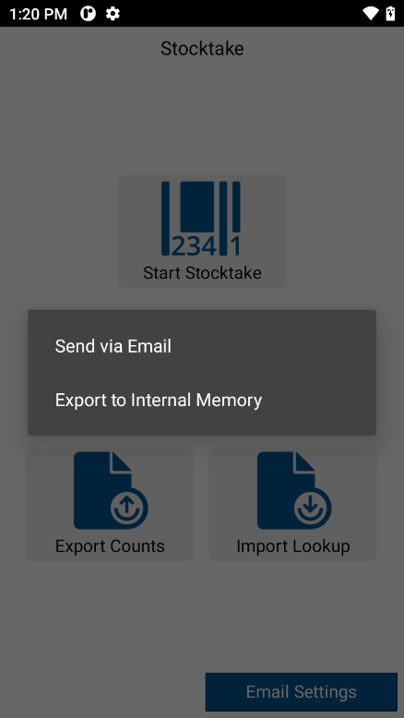

- If choosing Export to internal memory, select this. Then plug your USB cable into you PDA scanner and the other end into your PC.
- Pull the curtain (top of screen down) so you see these notifications. At the very bottom of screen, select Android System – Charging this device via USB. If you are not seeing this, swipe some messages to the right or left.
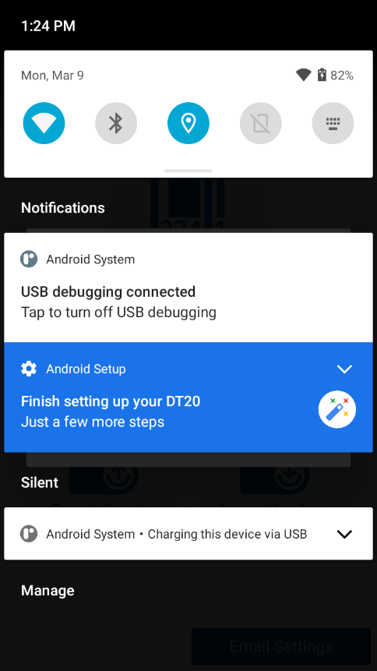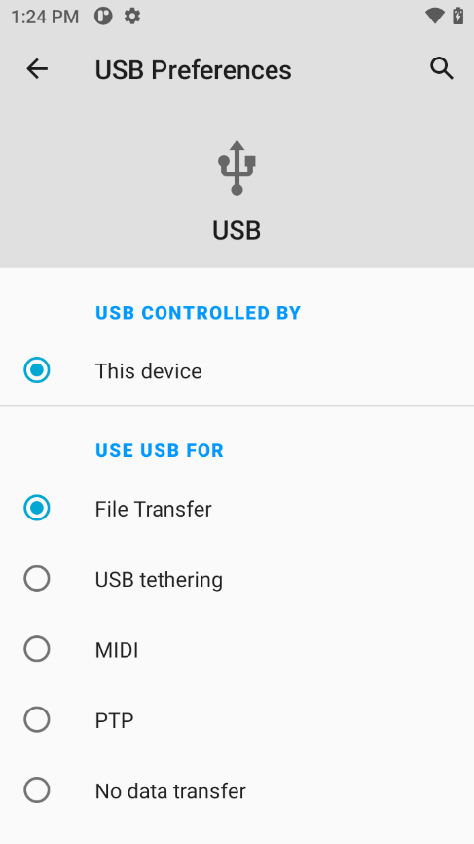
Also See Video - See Video below. https://go.screenpal.com/watch/c0hnhhVzCvJ
- Once you have successfully selected File Transfer, your PDA scanner becomes a USB peripheral. You should now be able to retrieve the stocktake data file.
- Go to File Explorer on your PC. You can see my DT20 PDA scanner in bottom left hand corner. I have clicked on to it and opened up all the folders in Internal storage.
- Now go and retrieve the REX_Counts file in Download folder.
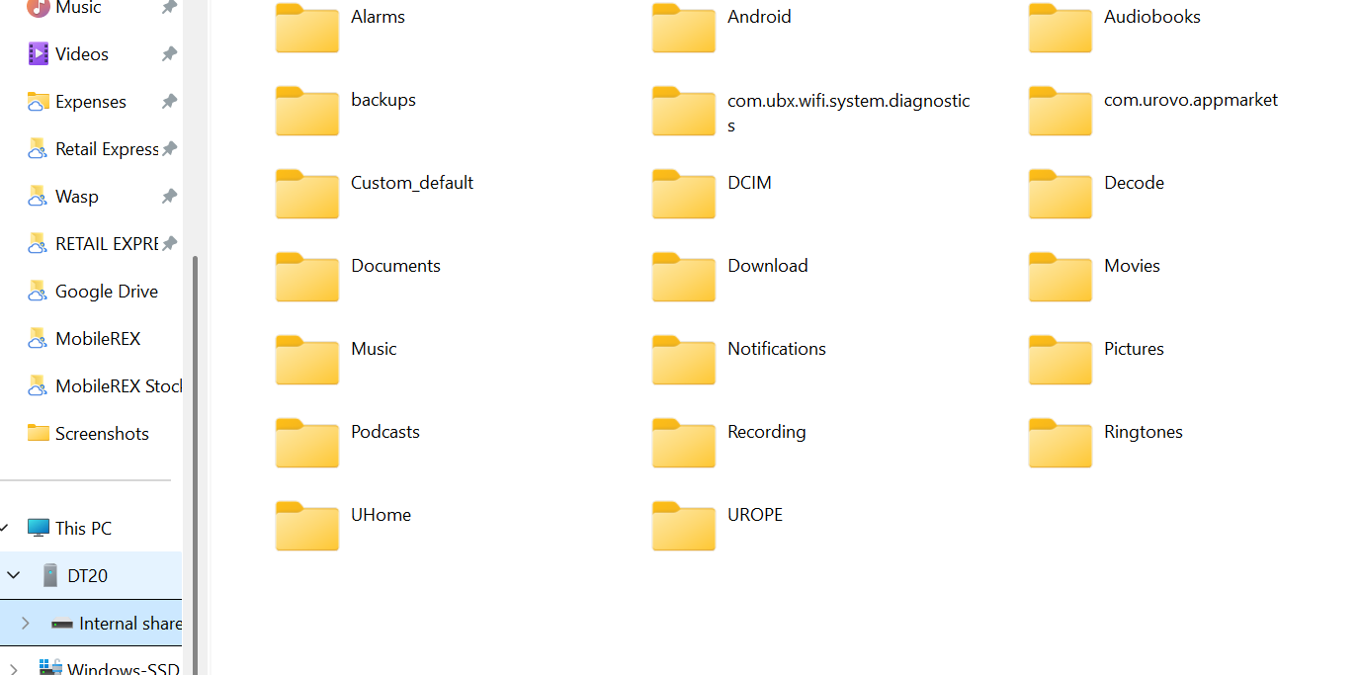
Looking at REX counts text file below in Download folder withinin PDA Scanner.
Copy this file and paste somewhere you can retrieve easily, like Desktop.

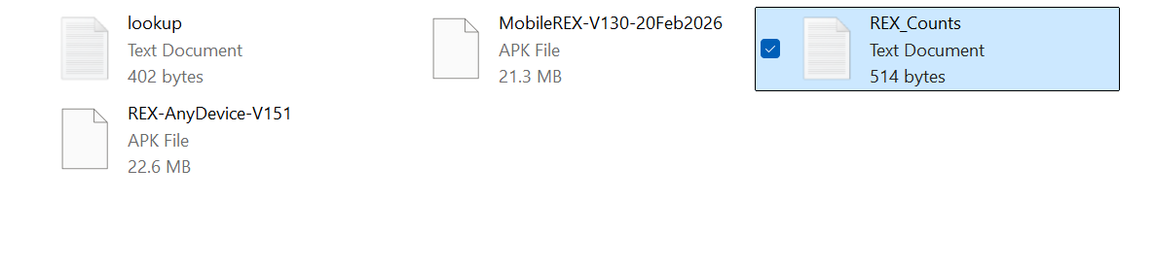
Details For Sending Stocktake Data Back to Retail Express - You cannot send your data (Rex Counts) collected from your stocktake scanners directly back into Retail Express. You have to use the Retail Express tool called Wireless Excel Scan tool for this.
The wireless excel scan tool allows you to compare what data is in your system to what you have counted with the stocktake scanners.
Firstly, you will first have to push all of your product information (via a mass product download report into the excel scan tool. You will then import your stocktake data file/s (Rex counts file) into excel scan tool via mobile import. Now you will be able to see any variances and make the necessary adjustments. Once happy with data in excel scan tool and there are no more variances, save as a csv file and send back into Retail Express.
LINK FOR EXCEL SCAN TOOL From RETAIL EXPRESS - Please contact Retail Express directly for this tool .
Here is the link to download the wireless excel scan tool:
https://galaxy.maropost.com/home/leaving?allowTrusted=1&target=https%3A%2F%2Fwww.retailexpressmedia.com%2Fdownloads%2Fsupport%2FExcelWirelessScanv5.xlsm
If the above link doesn't work, use the one below and click on the hyperlink 'Download the Excel Scan Tool now'
https://galaxy.maropost.com/kb/articles/421-stocktake-excel-advanced-with-a-barcode-scanner?utm_source=community-search&utm_medium=organic-search&utm_term=advance+stocktake
Please contact Retail Express if any questions and need support relating to Wireless Excel Scan tool.

Troubleshooting

📶 Stocktake (Live Mode) Running Slow – What to Check
If the Live version of Stocktake is running slowly, this is almost always related to Wi-Fi performance rather than the device or software.

✅ Before You Start (Recommended)
Always test Wi-Fi coverage across your store before using Live mode.
- Walk the store and scan a few items in different areas
- Confirm responses are quick and consistent
- Every site is different — walls, shelving, and distance all impact signal strength
👉 If Wi-Fi is strong across the entire store, Live mode will work well
👉 If signal is patchy, check below on Quick Fixes or consider using Local mode (loading lookup table) instead.

📡 How to Test Wi-Fi Signal
You can:
Option 1:
- Log into Stocktake function. Make sure API connection has been made first in local settings on MobileREX. Now simply scan items in different areas and check response speed
Option 2:
- Use a Wi-Fi analyser app like:
WiFi Analyzer (Open Source)
https://play.google.com/store/apps/details?id=com.vrem.wifianalyzer
This will show signal strength throughout the store and help identify weak spots.

⚠️ Common Causes of Slow Performance
- Distance from router or access point
- Walls, shelving, or obstacles blocking signal
- Weak or inconsistent Wi-Fi coverage
- Network congestion (too many devices connected)

🔧 Quick Fixes to Try
- Restart both:
  - Router
  - PDA scanner
- Ensure 2.4GHz Wi-Fi is enabled
  - Provides better range than 5GHz
  - Recommended for larger stores
- Set the PDA scanner to use 2.4GHz if possible.
- On your PDA scanner, Go to Settings / Network & Internet.
Turn off Wi-Fi and now select Wi-Fi when off. Now select WLAN band (Image 3). Now select 2.4GHZ
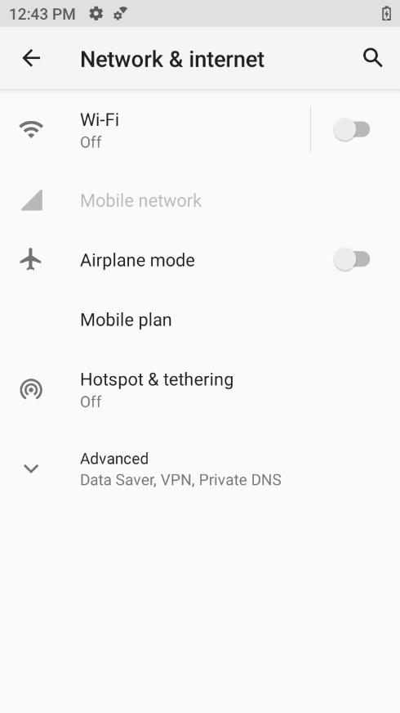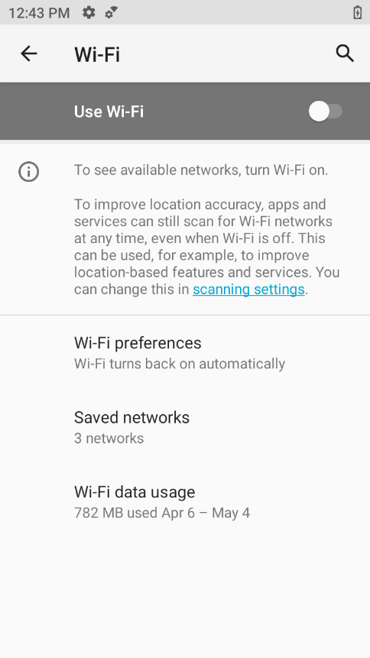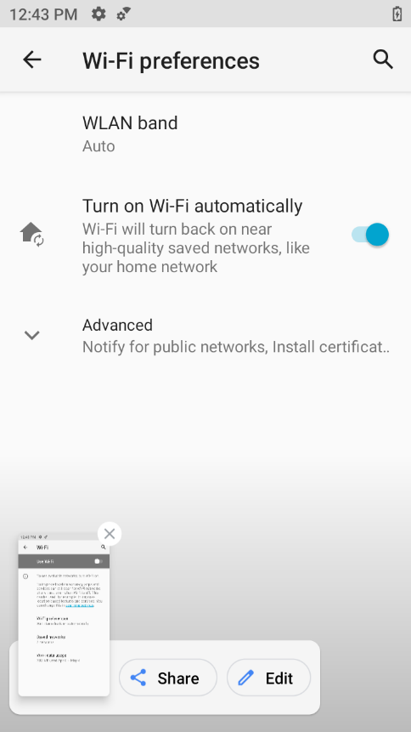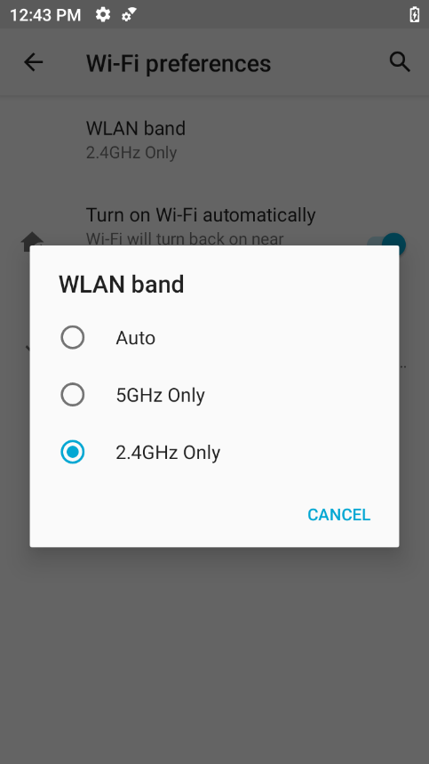
- Retry the stocktake after reconnecting

🧰 If Issues Continue
If performance is still slow after the above steps:
- The Wi-Fi network likely needs improvement
- This may include:
  - Adding access points
  - Improving coverage in weak areas
  - Network configuration changes
👉 These changes fall outside our scope and should be handled by your internal IT team or network provider

Track n Trace Contact Details.
